

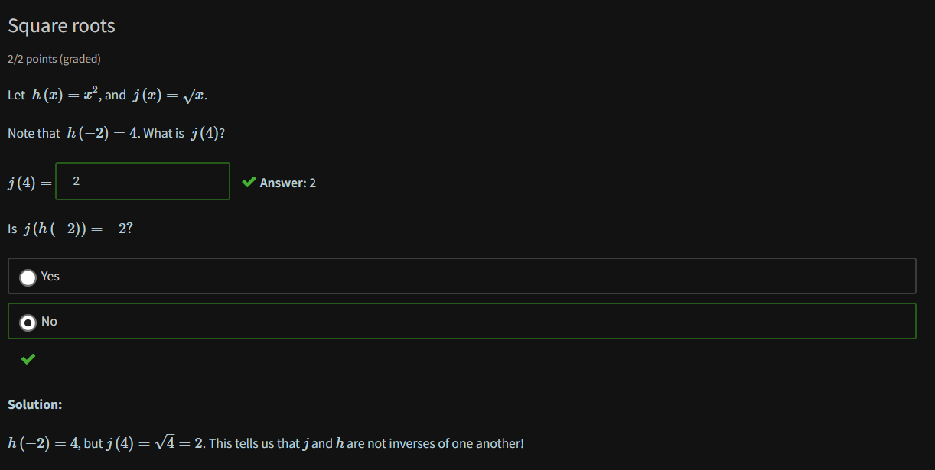

Determining functions that do not have inverse

Horizontal line test

* If on the test, it intersects 2 points of the graph, it does not have an inverse

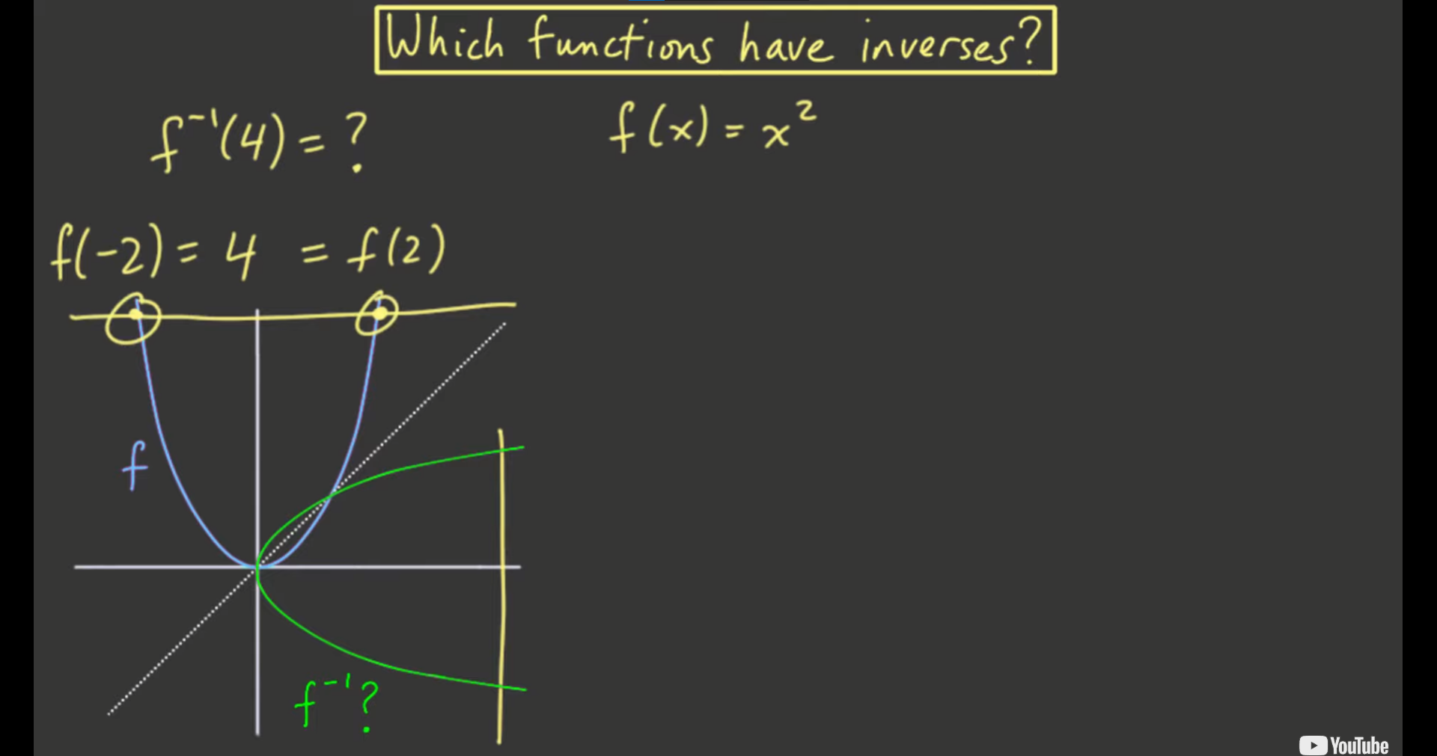

Try checking only halves: (Partial inverses)

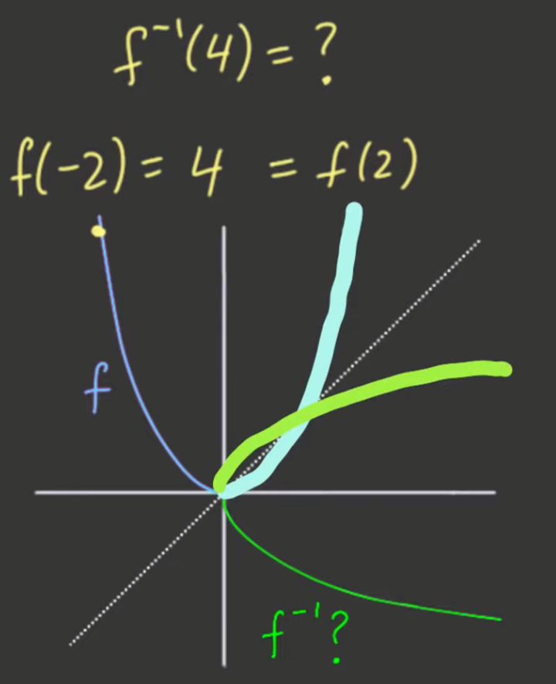 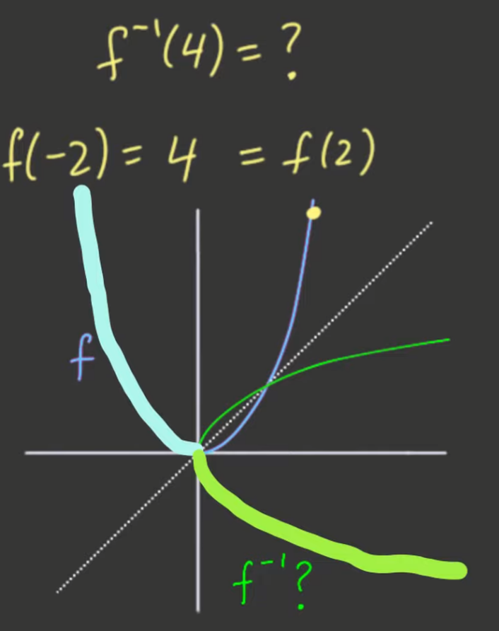

* This will satisfy the horizontal line test, intersect the graph at only one point, and look, it really has a reflection on the y=x diagonal

Complete Inverse Function

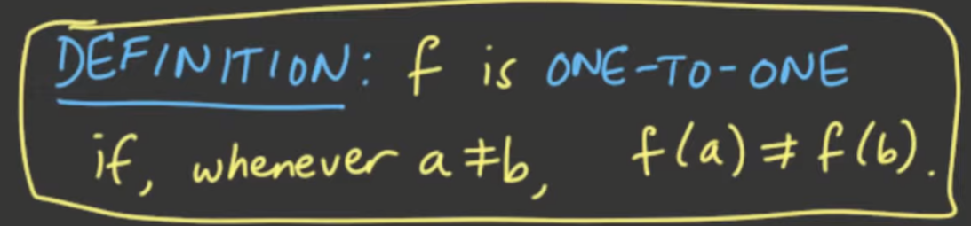

Example:

Given the cubic:

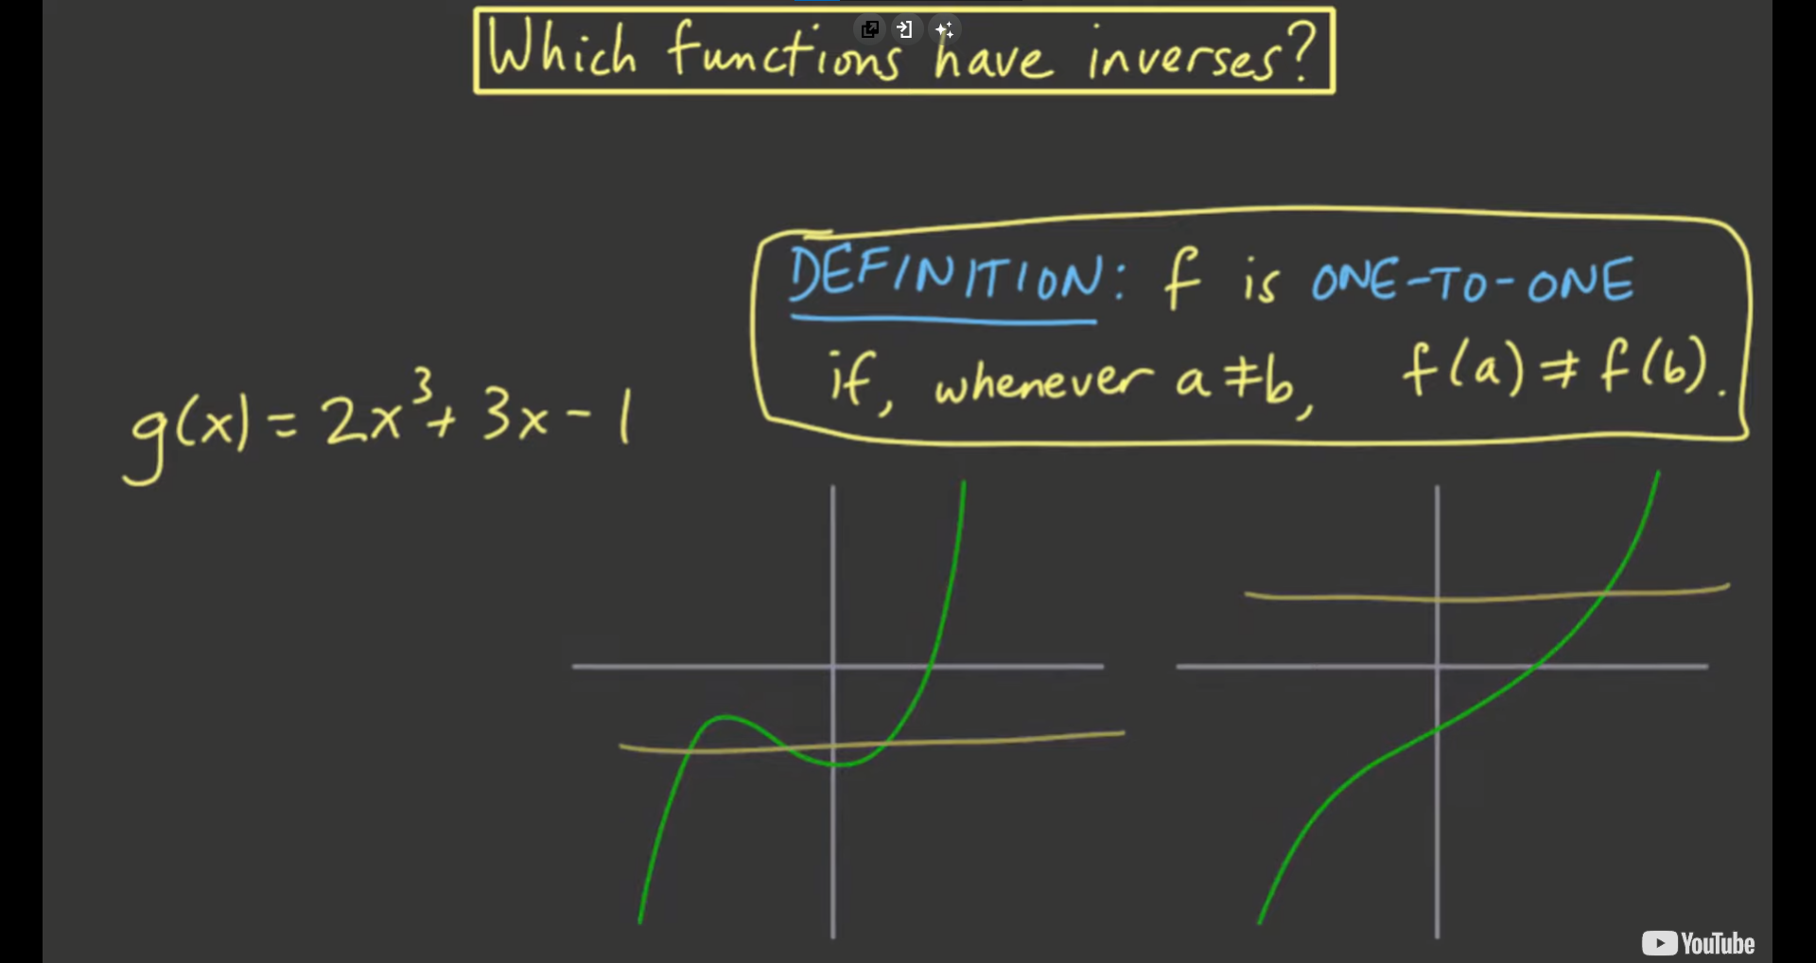

* Some cubics can pass or fail the horizontal line test
* Using algebra, it might be harder
  + You’ll solve first 3 values of x and then plot

Using calculus:

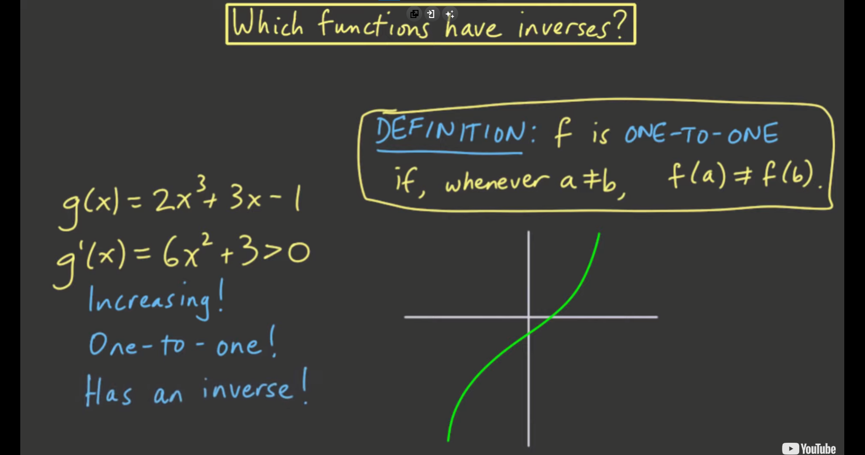

* Find the derivative
* Check if it is only in one direction

